Purpose
This document illustrates the results of the electrooxidation treatment implemented at SIN060 after 1.5 years of operations.
Executive summary
Following the successful pilot at SIN060 where a 1m3/hr electrooxidation (EO) system was operated from Aug 2022 to Jul 2023, an 8m3/hr system was implemented for water treatment of the entire site’s cooling tower recirculating water and commenced operations in Feb 2024. At full scale, the EO water treatment system has allowed for an improvement in the water usage efficiency (WUE) by 10% between 2023 and 2024. This was due to an improvement in water quality as the EO water treatment system was on average able to reduce >14% of hardness, >4% of conductivity and TDS, and >24% of COD. Additionally, the system produces free chlorine from the residual chloride in the water which is able to disinfect the water in the cooling tower loop. This demonstrates the effectiveness of the system and gives us confidence to scale it to other sites. AWS has completed the implementation at our data centers in Jakarta in Sep 2025 and will also commence installation at the rest of AWS Singapore data centers.
1. Background
Cooling tower operations naturally concentrate dissolved and suspended solids in the condenser loop as water evaporates. This concentration leads to increased conductivity and potential scaling issues, requiring periodic discharge of high-conductivity water through cooling tower blowdown (CTBD) and replacement with fresh makeup water. To optimize water usage and enable CTBD reuse, water treatment is required to remove dissolved solids from the system. The EO system removes ions through electrode reactions while simultaneously generating oxidizing agents. This process delivers multiple benefits: it reduces dissolved solids and conductivity, lowers pH and hardness levels, removes organic compounds, and produces free chlorine for natural disinfection. These improvements allow the cooling tower to operate at higher cycles of concentration while minimizing blowdown requirements. Additionally, the reduction in scaling leads to cleaner heat transfer surfaces, improving overall energy efficiency.
2. Results from SIN060
The EO system commenced operations in SIN060 from Feb 2024, at 8m3/hr treatment capacity. The summary of the results over the 18 months of operations are as follows: (1) average hardness removal of 14.3% (2) average conductivity removal of 4.1%, (3) average COD reduction of 24.2%, (4) average Silica removal of 14.4%, (5) average free chlorine generation of 0.2ppm (6) Heterotrophic plate count (CFU/ml) removal 90.5%. The trend of the improvement in water quality parameters is shown in Appendix A. These results were achieved with ~0.25kWh/m3 of energy for treatment which is very small compared to other methods of water treatment. WUE was also improved by 10% (trend shown in Appendix B).
3. How does this work?
The electrooxidation system is installed as a side stream treatment system in the condenser water loop. Ions are removed on the cathode and anode, reducing hardness and conductivity. By continuously reducing/extracting the hardness, conductivity, TDS and COD from the cooling tower loop water, the water remains within the allowable limits of the system for a longer duration. With the reduction in conductivity, the water can circulate for more cycles before reaching the conductivity setpoint for automatic blowdown, allowing for water savings.
As the EO treatment lowered the average values of hardness, TDS and COD circulating within, AWS made the decision to increase the conductivity setpoint from 1300uS/cm to 1500uS/cm in Oct 2024, without exceeding the limits for the other water quality parameters (see Appendix C). This further allows the water to remain in circulation longer, before automatic blowdown, hence reducing water consumption for make-up water to the cooling tower. This has increased the COC from ~13 to >15.
4. Operation and Maintenance
The EO system requires minimal human interface and much less maintenance compared to RO system. Human intervention is only required when an alarm is triggered. The pressure and flow transmitters can be read locally and can be connected to the Building Management System (BMS) for easy monitoring.
Cleaning of the electrodes is only required on a quarterly basis, due to deposition of hardness (e.g. calcium carbonate, silicon oxide). No chemicals are required for cleaning, as mechanical cleaning/brushing is sufficient to remove the hardness deposition on the electrodes. This waste can be disposed of as general waste. The maintenance cost of the system including water sampling, system checks, and cleaning is relatively minimum. The electrodes are estimated to have a lifespan of 10-15 years.
5. Return on Investment
With PUB Water Efficiency Funding (WEF) of ~50% of CAPEX, and savings from water bills, an ROI of approximately 6 years is achievable. With the maturing of this technology, and economies of scale, we expect the CAPEX cost to further decrease. In addition, the improved water quality will reduce scaling in the system and improve the efficiency of heat transfer in the chiller, allowing for further energy savings not quantified above. The approach temperature can be monitored and measured as an indication on the effectiveness of reduced scaling.

6. Recommendations
The data collected for the 1.5-year period demonstrates that the use of EO technology can lower water usage by significantly lower cooling system blowdown and allow cooling system to operate at a higher cycle of concentration (COC). In addition, the improved water quality is also expected to reduce corrosion and damage to the cooling tower system. The results provide confidence for scaling-up of the system to other data center sites, and AWS has proceeded with investing in implementing EO system in CGK and other SIN data centers from 2Q2025.
Appendix A: SIN060 1.5-Year Results.
Figure A.1: Below chart showing before and after treatment value and removal rate of the Total Hardness, b) Total Alkalinity and c) calcium removal with respect to the date.
In Summary: 14% of hardness, 4% of conductivity, 14% calcium, 19% magnesium reduction
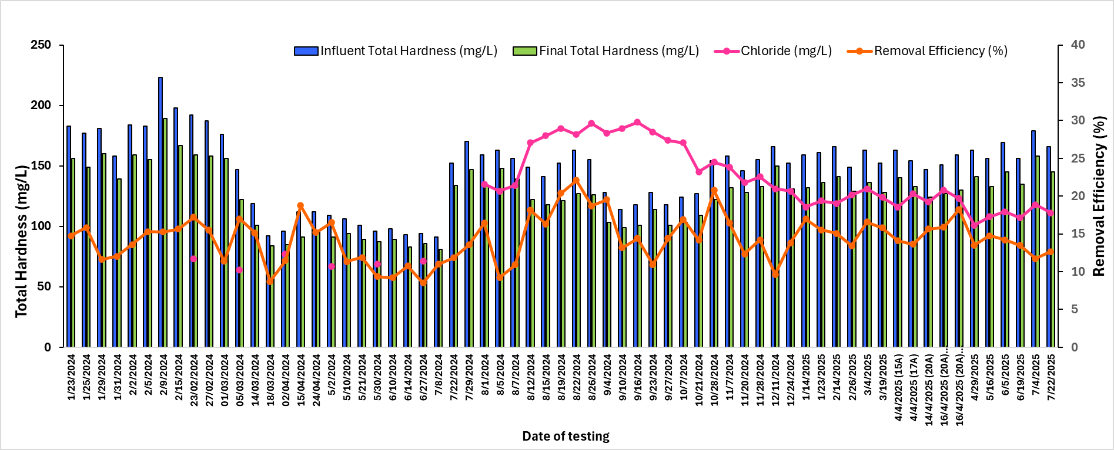
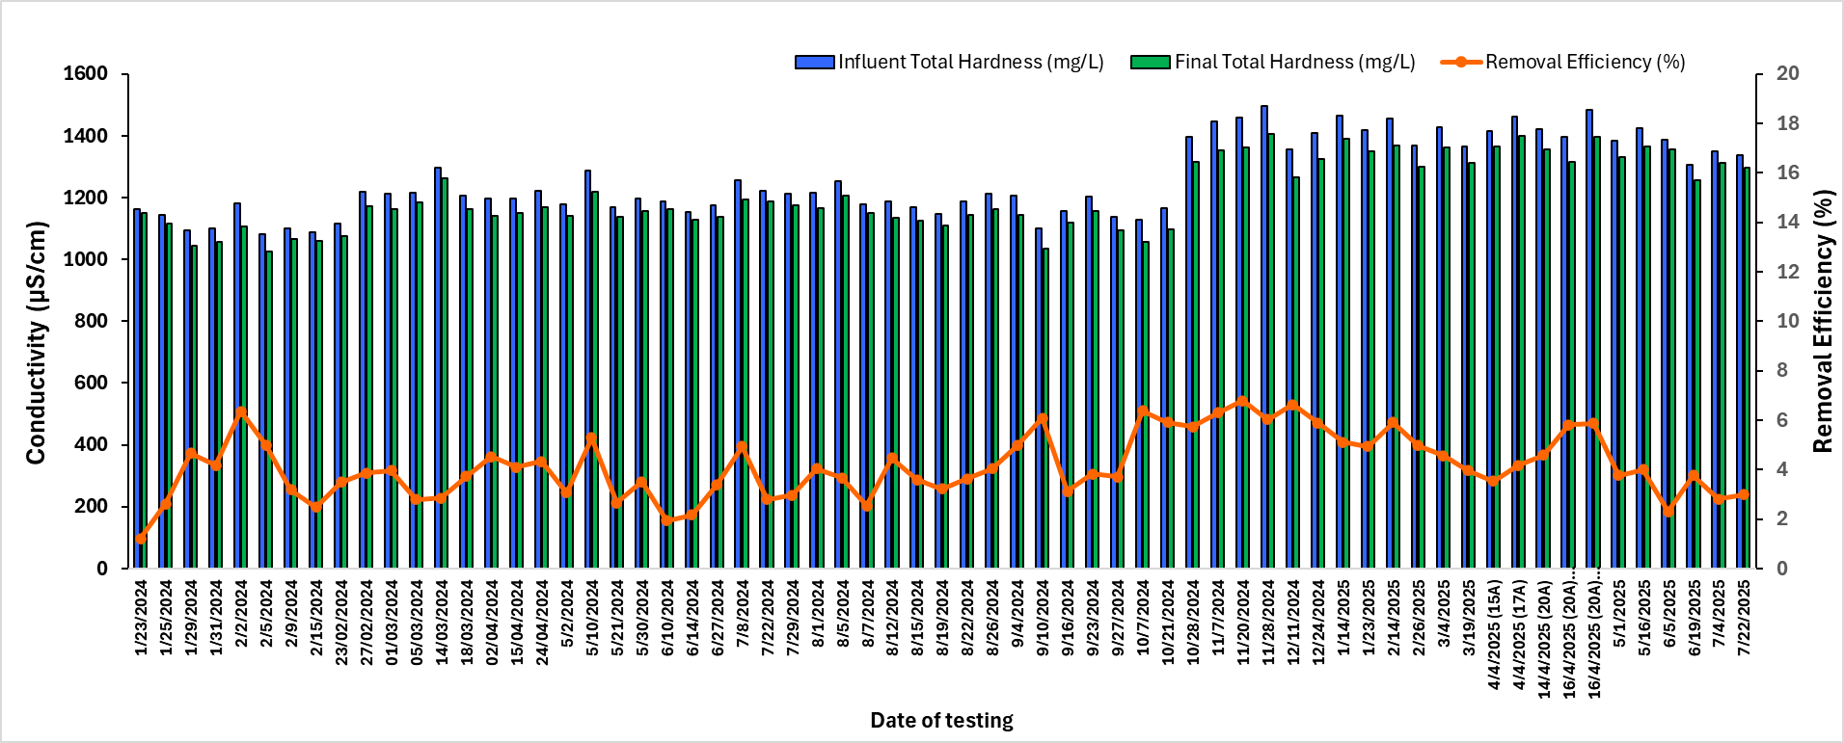
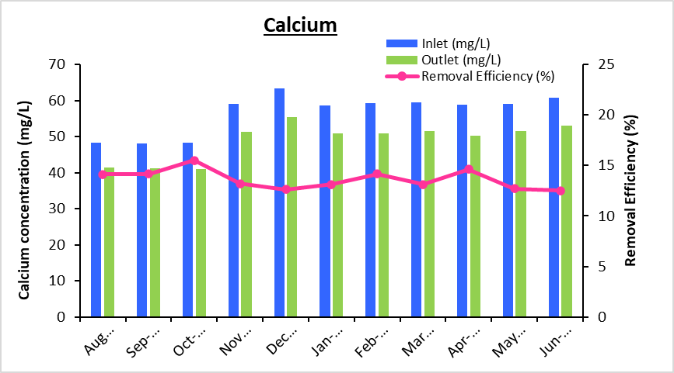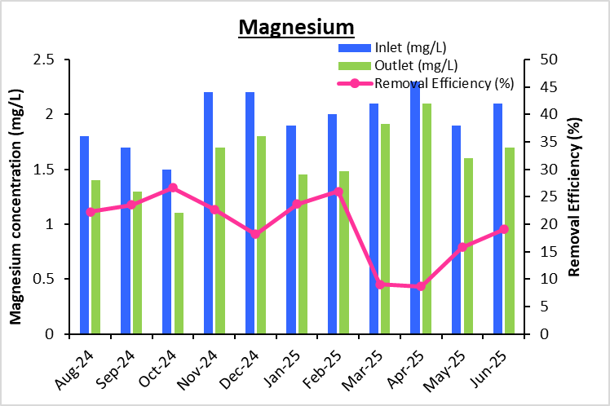
Figure A.2: Below chart showing removal of Chloride by 6% and Sulphate by 10%
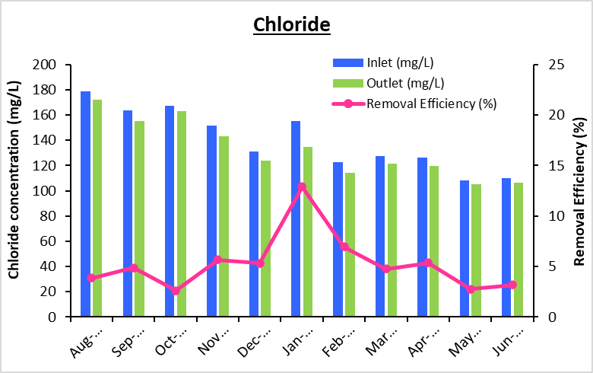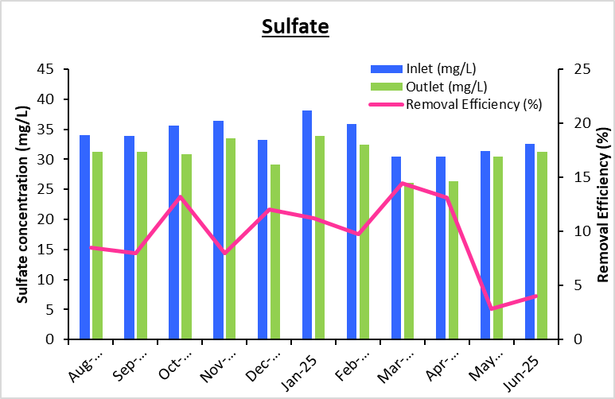
Figure A.3: Below chart showing removal of COD by 24%
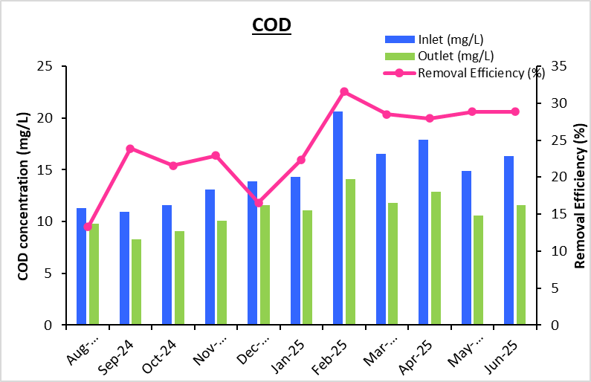
Figure A.4: Below chart showing removal of Silica around 14%
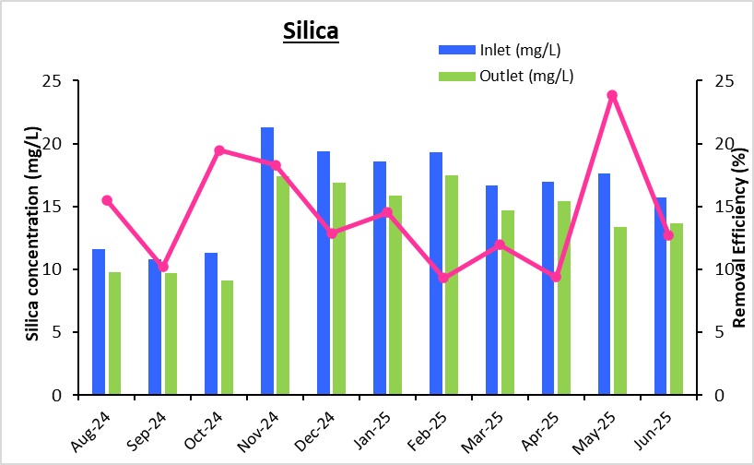

Appendix B: WUE Trend Pre and Post Implementation (up till 2Q2025)
Figure B.1: WUE downtrend observed from 1Q 2024

Appendix C: Increase in Conductivity Setpoint in Oct 2024
Figure C.1: Below chart showing effects of increase in conductivity setpoint (1300uS/cm to 1500uS/cm) on hardness (limit: 500ppm) and alkalinity (limit 450ppm)

